Project Title: Smart Lender - Applicant Credibility Prediction for Loan Approval Project Design Phase-I - Solution Fit Template Team ID: PNT2022TMID49957

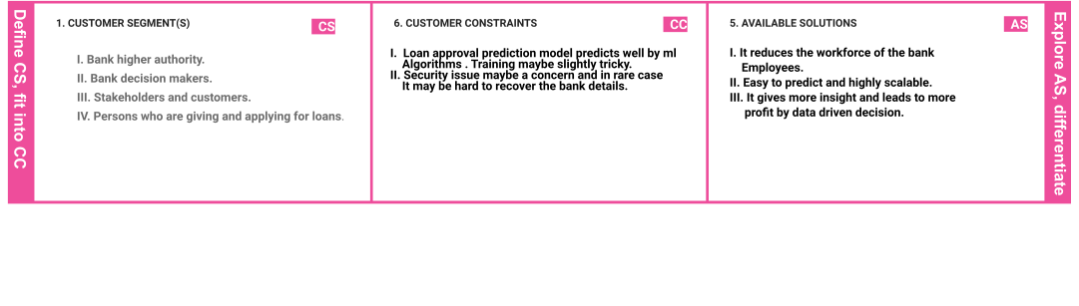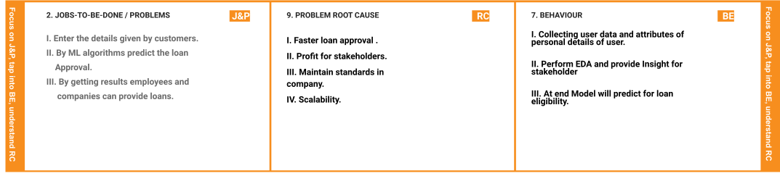

|  |  |  |  |  |  |  |
| --- | --- | --- | --- | --- | --- | --- |
|  | **3. TRIGGERS** | **TR** | **10. YOUR SOLUTION**   1. **Providing cleaner visuals to stakeholders.** 2. **Helping higher level and employees to take data driven decision.** 3. **More accuracy ML model for predicting customer data.** 4. **Highly scalable - Transfer learning allows high**   **scalability and can be used across different level and locations of particular bank or ﬁnance**  **Company.** | **SL** | 1. **CHANNELS of BEHAVIOUR CH**    1. **ONLINE**   **Online loan approval system - By online services of company customers can know their loan eligibility.**   * 1. **OFFLINE**   **Bank and ﬁnance - Employees can work easily in oﬄine and provide customer satisfaction in least effort** |  |
| **I. Scope of ML and data science increases** |  |
| **day by day.** |  |
| **II. Financial and Banks are in need of faster** |  |
| **loan approval model.** |  |
| **4. EMOTIONS: BEFORE / AFTER EM** | |
| **Before : Lots of workload and pressure to check and provide loan eligibility , It needs lots of human or labor force.** | |
| **After : Easy , scalable and rapid approval in predicting and providing loans to customers.** | |